##### **Byte Stream**

Read/write in flow of byte(8bits).

InputStream and OutputStream are two parent classes.

##### **Character Stream**

Read/write in flow of 2-bytes.

Reader and Writer are two parents classes.

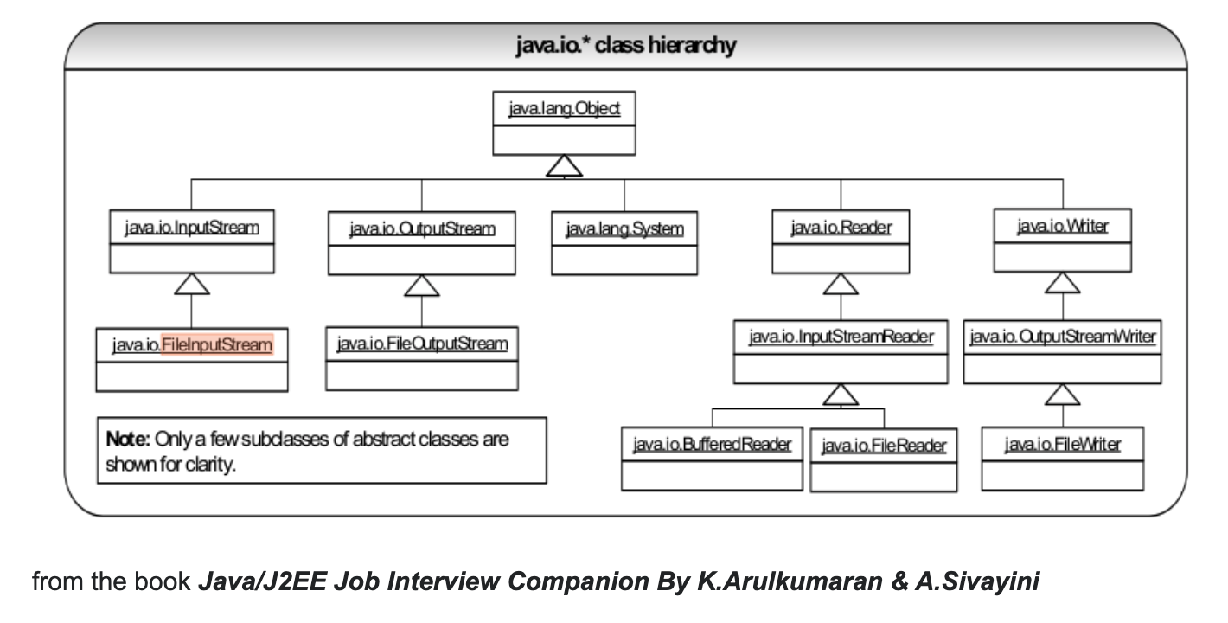

##### **Serialization & Deserialization**

Serialization is a mechanism of converting the state of an object into a byte stream. Deserialization is the reverse process where the byte stream is used to recreate the actual Java object in memory. This mechanism is used to persist the object.

<https://www.youtube.com/watch?v=L6w883SGuOM>